Unit 2
Introduction to Computer Networks
[5 Hrs]

2.1 Definitions, Uses, Benefits
2.2 Network Topologies and its types (Bus, Star, Ring, Mesh, Hybrid)
2.3 Types of Computer Networks (PAN, LAN, MAN, WAN, CAN)
2.4 Networking Types (Client/Server, P2P)
2.5 Overview of Protocols and Standards
2.6 OSI Reference Model
2.7 TCP/IP Models and its Comparison with OSI
2.8 Networking Hardware: NIC, Hub, Repeater, Switch, Bridge, Router
2.9 Basic Networking Commands

2.1 Definitions, Uses, Benefits
Definition of Computer Network  A computer network is a collection of two or more computers or devices connected together to share data, resources, and services.  These devices may be connected using:  - cables  - fiber optics  - Wi-Fi  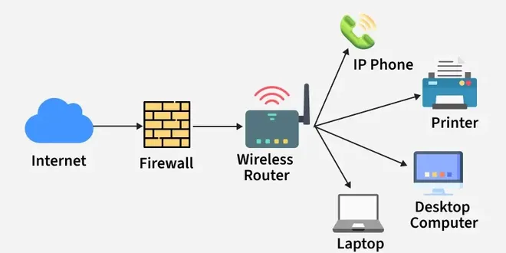  - radio waves  When computers communicate and share resources with each other, it is called a computer network.  Examples of a Computer Network  - computers connected in a school lab  - office computers sharing one printer  - mobile phone using Wi-Fi internet  - ATM network of banks  - hospital computers sharing patient records  Benefits of Computer Networks  1. Cost Saving  Instead of buying separate printers, storage, and internet for each computer, devices can share them.  2. Easy Communication  Users can exchange information quickly.  3. Better Data Management  Data can be stored centrally and managed efficiently.  4. Increased Reliability  Backup systems and multiple connections can improve reliability.  5. Scalability  New devices can be added easily.  6. Collaboration  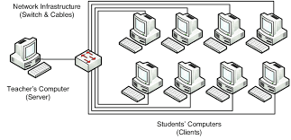  Many users can work together on project | Uses of Computer Networks  Computer networks are used for many purposes:  1. Resource Sharing  Devices can share:  - printer  - scanner  - storage  - internet connection  Example:  In a college office, many computers may use one printer through a network.  2. Data Sharing  Users can send and receive:  - files  - documents  - photos  - videos  Example:  A teacher sends notes to students through the college network.  3. Communication  Networks help people communicate through:  - email  - chat  - video call  - voice call  Example:  A team meeting can be done using Zoom or Google Meet over a network.  4. Centralized Management  Data and software can be controlled from one central server.  Example:  In a bank, all branch computers may connect to a central database server.  5. Remote Access  Users can access information from distant places.  Example:  A person in Butwal can access a server in Kathmandu through the internet.

2.2 Network Topologies
Network topology means the physical or logical arrangement of computers and network devices in a network.  In simple words, it shows how devices are connected.  1. Bus Topology  In bus topology, all devices are connected to a single main cable called the backbone cable.  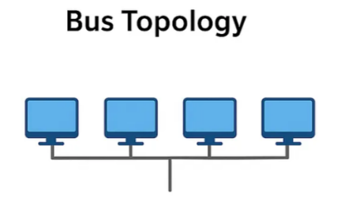  Structure:  All computers share one communication line.  Example:  A small old office network where all computers connect to one long cable.  Advantages:  - simple to install  - low cost  - less cable required  Disadvantages:  - if main cable fails, whole network fails  - difficult to troubleshoot  - performance decreases with more devices  2. Star Topology  In star topology, all devices are connected to a central device such as a hub or switch.  Structure:  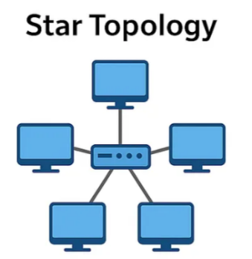  Each computer has a separate cable to the central device.  Example:  Most modern school and office LANs use star topology.  Advantages:  - easy to install and manage  - failure of one cable affects only one device  - easy to expand  Disadvantages:  - if central device fails, entire network fails  - needs more cable | 3. Ring Topology  In ring topology, each device is connected to two neighboring devices, forming a circular path.  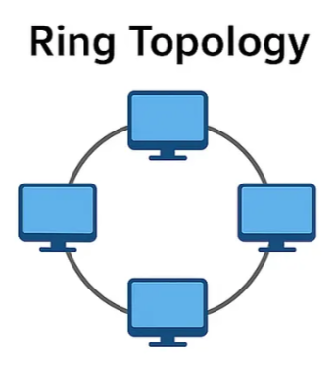  Structure:  Data travels around the ring.  Example:  Older token ring networks.  Advantages:  - orderly data transmission  - less collision  Disadvantages:  - failure in one node/cable may affect whole network  - difficult to reconfigure  4. Mesh Topology  In mesh topology, every device is connected to every other device.  Structure:  Multiple paths exist between devices.  Example:  Critical military or research communication systems.  Advantages:  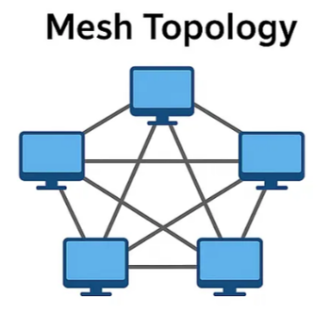  - very reliable  - high fault tolerance  - secure communication  Disadvantages:  - very expensive  - large amount of cabling  - difficult installation  5. Hybrid Topology  A hybrid topology is a combination of two or more topologies.  Example:  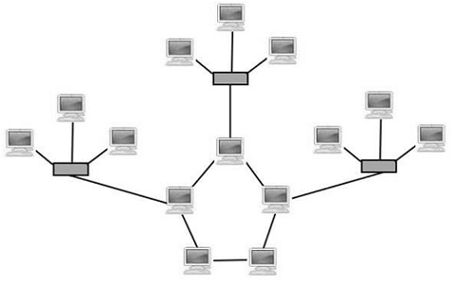  A college network may use star topology inside each department and combine departments in another form.  Advantages:  - flexible  - scalable  - can combine strengths of different topologies  Disadvantages:  - complex design  - higher cost

2.3 Types of Computer Networks
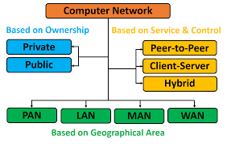  Computer networks can be classified according to their size and coverage area.  1. PAN – Personal Area Network  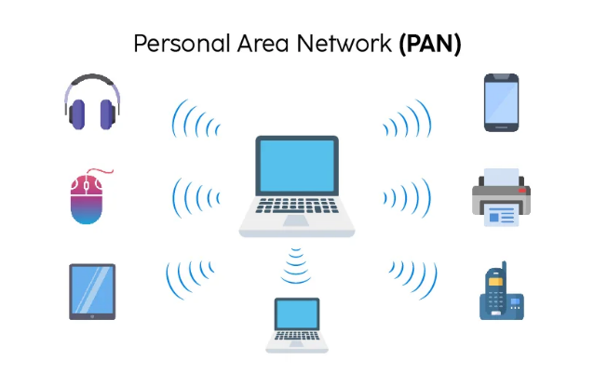  A PAN is a small network around one person.  Range:  Very short distance, usually a few meters.  Examples:  - Bluetooth connection between phone and earbuds  - phone connected to laptop hotspot  Use:  Personal devices communication.  2. LAN – Local Area Network  A LAN connects computers within a small area such as:  - room  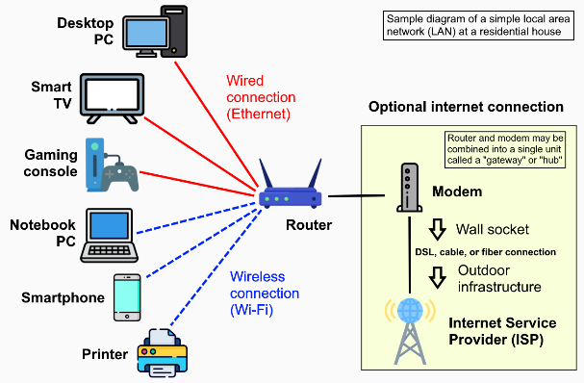  - home  - office  - school lab  Example:  A computer lab in a college.  Features:  - high speed  - private ownership  - low cost | 3. MAN – Metropolitan Area Network  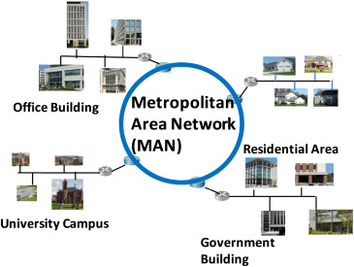  A MAN covers a city or town.  Example:  A network connecting different offices of a company across Butwal city.  Features:  - larger than LAN  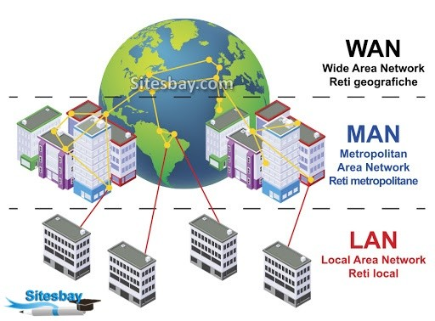  - smaller than WAN  4. WAN – Wide Area Network  A WAN covers a large geographical area such as:  - country  - continent  - world  Example:  The internet is the best example of WAN.  Features:  - connects distant networks  - may use leased lines, fiber, satellite  5. CAN – Campus Area Network  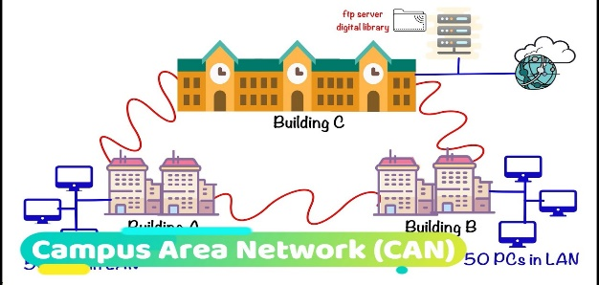  A CAN connects multiple LANs within a campus or institution.  Example:  A university network connecting administration block, library, labs, and hostels.  Features:  - larger than LAN  - smaller than MAN  common in colleges and hospitals

2.4 Networking Types (Client/Server, P2P)
1. Client/Server Network  In a client/server network, one or more computers act as servers, and others act as clients.  Server  A server provides:  - files  - database  - printer service  - web service 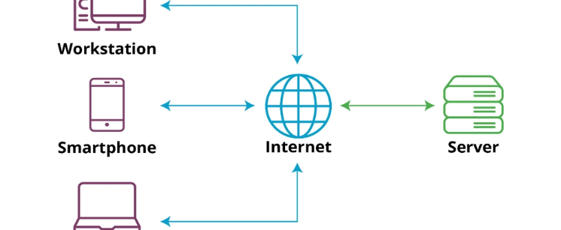  Client  A client requests services from the server.  Example:  In a bank, employees’ computers act as clients and connect to a central database server.  Advantages:  - centralized control  - better security  - easy backup  - efficient management  Disadvantages:  - expensive  - server failure affects many users  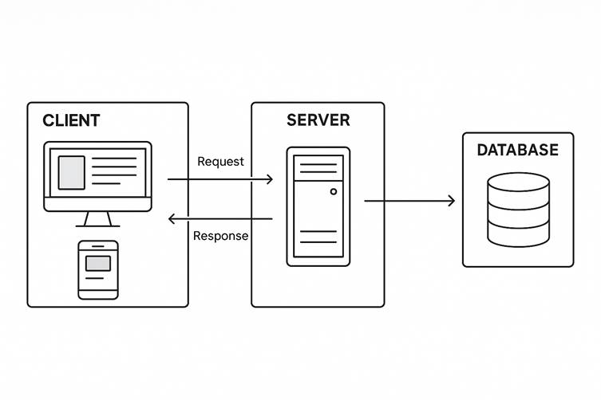  - requires administration | 2. Peer-to-Peer (P2P) Network  In a peer-to-peer network, all computers are equal.  Each computer can act as both client and server.  Example:  Two computers sharing files directly in a small office.  Advantages:  - simple  - low cost  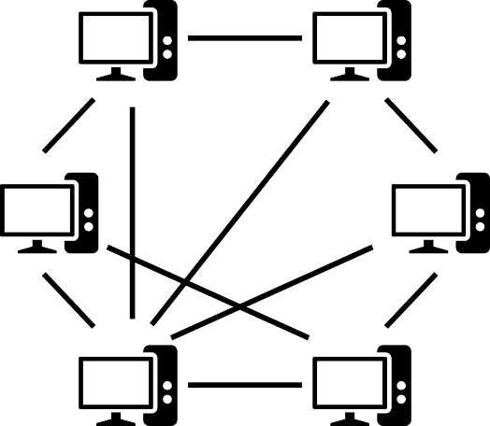  - no dedicated server needed  Disadvantages:  - less security  - difficult management  - not suitable for large networks  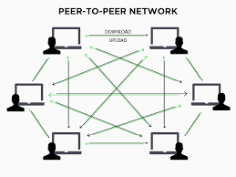

2.5 Overview of Protocols and Standards
Protocol  A protocol is a set of rules used for communication between devices.  Protocols define:  - how data is formatted  - how it is sent  - how it is received  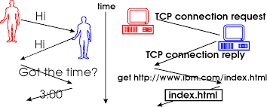  - how errors are handled  Protocols are rules for communication between network devices. Standards ensure compatibility among devices and technologies. Both are necessary for successful computer networking.  Examples:  - HTTP  - HTTPS  - FTP  - TCP  - IP  - SMTP  Standard  A standard is an agreed rule or guideline followed by manufacturers and organizations to ensure compatibility.  Example:  Wi-Fi standards allow devices from different companies to connect. | Why Protocols and Standards are Important  - ensure communication between different devices  - make networking reliable  - support interoperability  - reduce confusion  - improve compatibility  Examples of Common Protocols  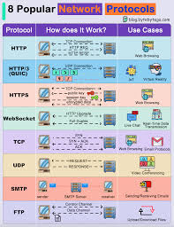  HTTP  Used for web browsing.  HTTPS  Secure version of HTTP.  FTP  Used for file transfer.  SMTP  Used for sending email.  TCP  Provides reliable data delivery.  IP  Handles addressing and routing.  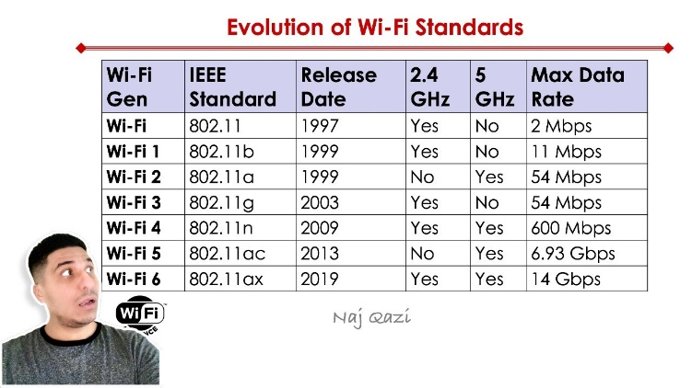

2.6 OSI Reference Model
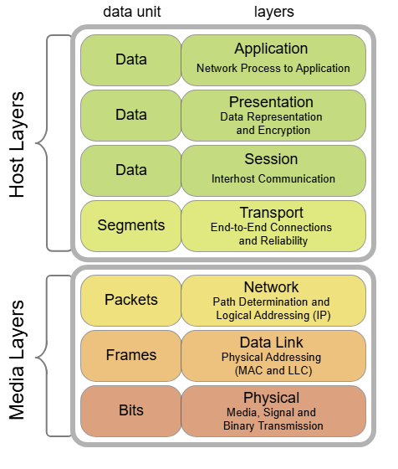  The OSI Model stands for Open Systems Interconnection Model.  It is a conceptual framework that explains how data moves from one device to another through a network.  It has 7 layers.  The OSI reference model has seven layers: Physical, Data Link, Network, Transport, Session, Presentation, and Application.  Each layer has a specific function and helps in structured network communication.  1. Physical Layer  Responsible for transmitting raw bits through the medium.  Functions:  - cables  - connectors  - signal transmission  Example:  Ethernet cable, hub  2. Data Link Layer  Responsible for node-to-node delivery and error detection.  Functions:  - framing  - MAC addressing  - error detection  Example:  Switch, NIC  3. Network Layer  Responsible for logical addressing and routing.  Functions:  - IP addressing  - routing  Example:  Router | 4. Transport Layer  Responsible for end-to-end delivery.  Functions:  - segmentation  - flow control  - error control  Example:  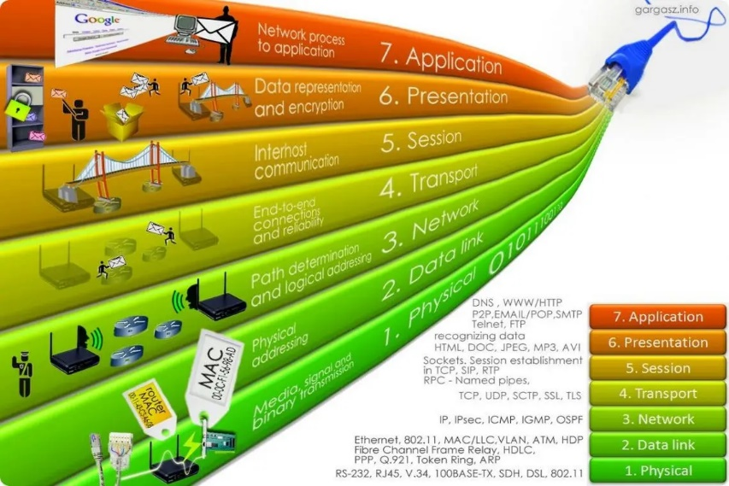  TCP, UDP  5. Session Layer  Responsible for establishing, managing, and terminating sessions.  Example:  Login session between systems.  6. Presentation Layer  Responsible for data translation, encryption, and compression.  Example:  Data format conversion, SSL  7. Application Layer  Closest to the user; provides network services to applications.  Examples:  HTTP, FTP, SMTP, DNS  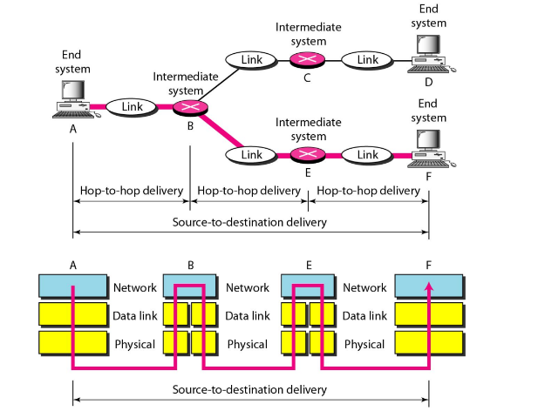

2.7 TCP/IP Models and its Comparison with OSI
Introduction  The TCP/IP model is a networking model used in real computer networks, especially on the Internet.  It explains how data moves from one device to another.  TCP/IP stands for:  - TCP = Transmission Control Protocol  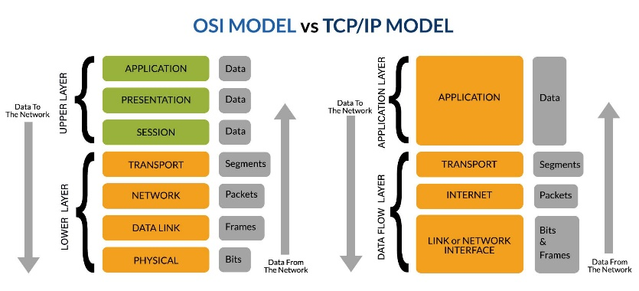  - IP = Internet Protocol  The TCP/IP model is simpler than the OSI model and has 4 layers.  Layers of TCP/IP Model  1. Application Layer  This layer provides services directly to user applications.  It combines the functions of:  - Application layer  - Presentation layer  - Session layer  of the OSI model.  Examples of protocols:  - HTTP  - HTTPS  - FTP  - SMTP  - DNS  Functions:  - file transfer  - email  - web browsing  - remote login  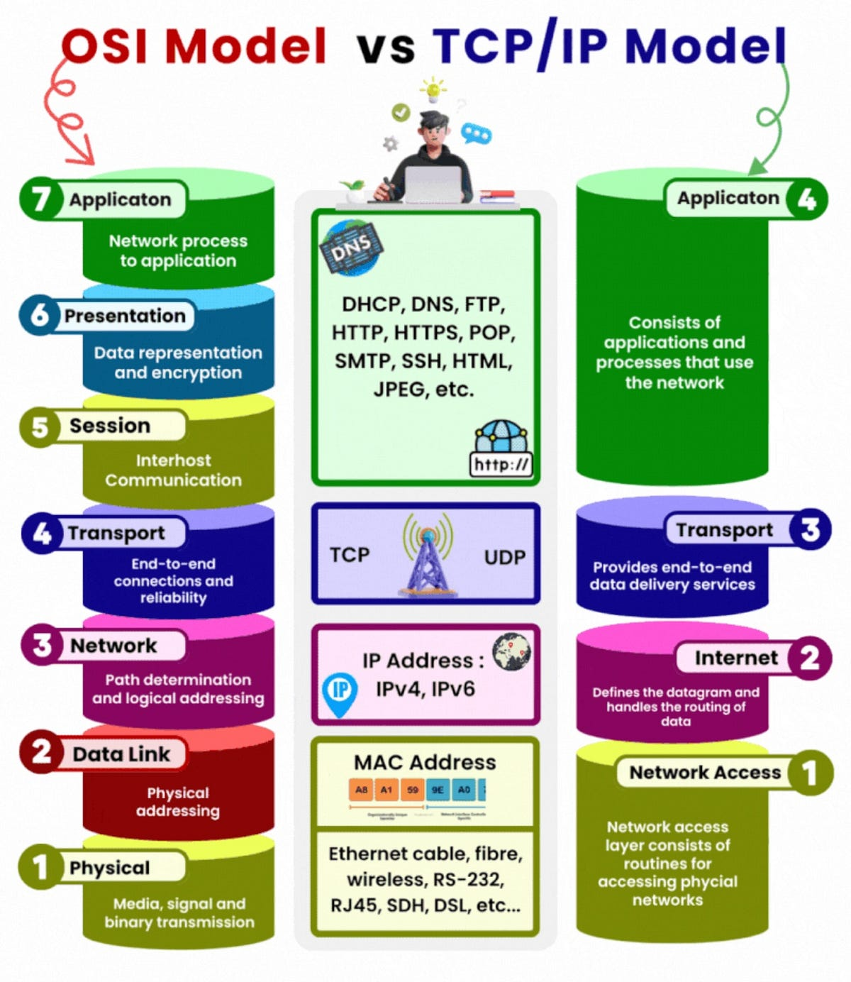 | 2. Transport Layer  This layer is responsible for end-to-end communication between source and destination.  Examples of protocols:  - TCP  - UDP  Functions:  - segmentation  - flow control  - error control  - reliable delivery  3. Internet Layer  This layer is responsible for logical addressing and routing.  Example of protocol:  - IP  Functions:  - IP addressing  - packet routing  - path selection  4. Network Access Layer  This is the lowest layer of TCP/IP model.  It handles actual transmission of data through the physical network.  It combines the functions of:  - Data Link layer  - Physical layer  of the OSI model.  Functions:  - framing  - MAC addressing  - transmission of bits  - error detection at local link  Comparison Between TCP/IP and OSI  OSI Model TCP/IP Model  7 layers 4 layers  Theoretical model Practical model  Developed by ISO Developed by DARPA  Session and Presentation are separate Session and Presentation are included in Application layer  Physical and Data Link are separate Combined as Network Access layer  Used for understanding network concepts Used in real Internet communication

2.8 Networking Hardware:

Networking hardware are the physical devices used to build and operate a computer network. These devices help computers communicate, send data, receive data, and connect different parts of a network.
The main networking hardware are:
- NIC
- Hub
- Repeater
- Switch
- Bridge
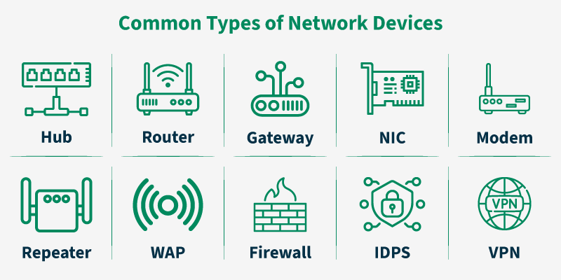
- Router

1. NIC (Network Interface Card)
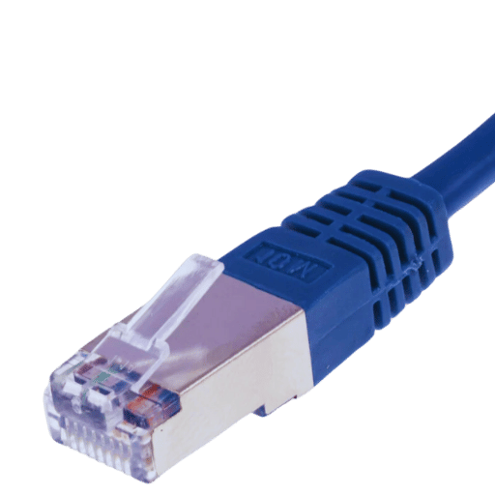
A NIC is a hardware component that allows a computer or device to connect to a network.
It may be:
- wired NIC
- wireless NIC
Functions:
- connects computer to network
- provides physical address called MAC address
- sends and receives data
Example:
- Ethernet card in desktop computer
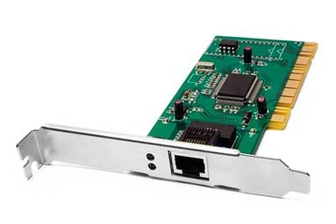
- Wi-Fi adapter in laptop
Simple example:
If a computer wants to connect to the internet through LAN cable, it needs a NIC.

2. Hub
A hub is a simple networking device that connects multiple computers in a network.
When a hub receives data from one device, it sends that data to all connected devices.
Functions:
- connects multiple devices
- broadcasts data to all ports
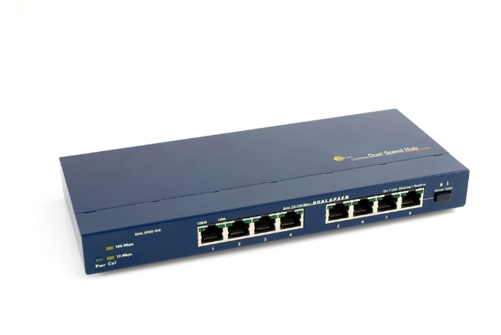
Advantages:
- simple
- low cost
Disadvantages:
- sends data to all devices
- causes more traffic
- less secure
- less efficient
Example:
Old small office networks used hubs to connect computers.

3. Repeater
A repeater is a device that regenerates or strengthens weak signals.
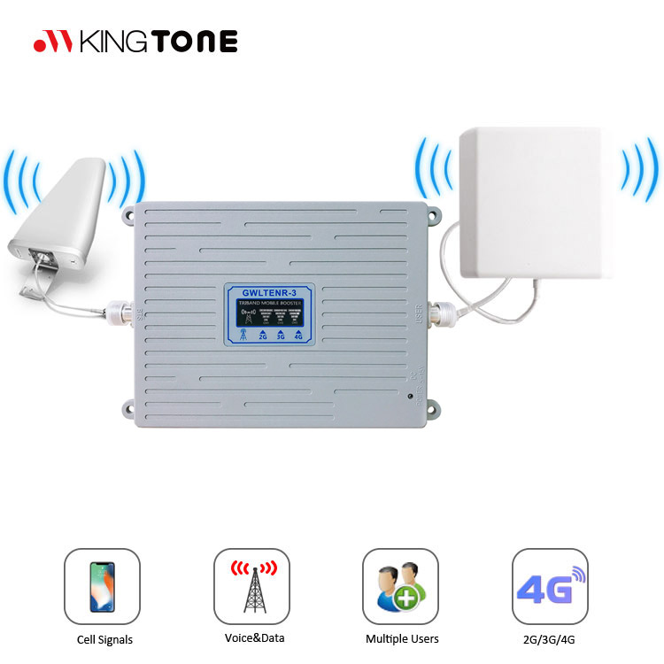
When data travels a long distance, the signal becomes weak. A repeater refreshes the signal and sends it again.
Functions:
- receives weak signal
- regenerates signal
- extends transmission distance
Example:
If a LAN cable is very long, a repeater can be used to extend the network.

4. Switch
A switch is a networking device that connects multiple computers in a LAN and sends data only to the correct destination device.
Unlike a hub, a switch does not broadcast to all devices unnecessarily.
Functions:
- connects multiple devices
- forwards data to specific device
- uses MAC address table
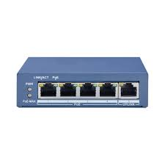
Advantages:
- faster than hub
- less traffic
- more secure
- better performance
Example:
Modern computer labs and offices use switches.
Simple example:
If computer A sends data to computer B, the switch sends it only to B, not to all computers.

5. Bridge
A bridge is a device that connects two LAN segments and filters network traffic.
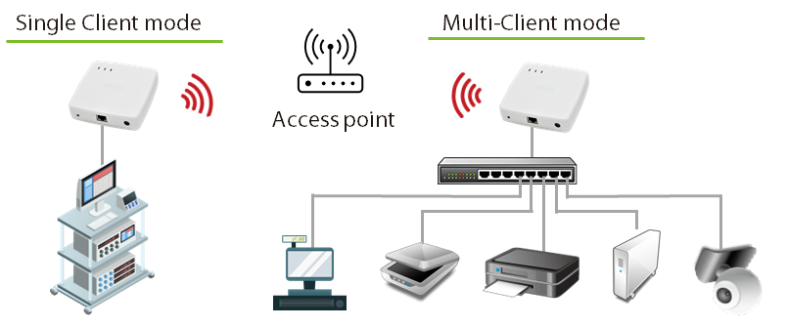
It works at the data link layer and uses MAC addresses.

Functions:
- connects two parts of a network
- reduces unnecessary traffic
- filters data
Example:
If one office network is divided into two parts, a bridge can connect them.
Advantage:
- reduces collision
- improves performance

6. Router
A router is a networking device that connects different networks and routes data packets from one network to another.
It works using IP addresses.
Functions:
- connects different networks
- chooses best path for data
- routes packets
- connects LAN to internet
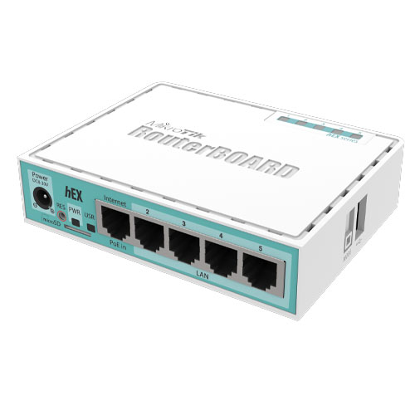
Example:
Home Wi-Fi router connects your home network to the internet.
Simple example:
If your laptop accesses a website, the router forwards your request from local network to the internet.

2.9 Basic Networking Commands

Basic networking commands are used to:
WIN + R , CMD
- check network connection
- test communication between devices
- view IP address
- troubleshoot internet problems
- check routes, DNS, and ports
These commands are very useful for students, network administrators, and computer users.

A. Basic Networking Commands in Windows
1. ipconfig
This command shows the basic IP configuration of the computer.
Use:
- view IP address
- view subnet mask
- view default gateway
Command:
ipconfig
Example output:
- IPv4 Address: 192.168.1.10
- Subnet Mask: 255.255.255.0
- Default Gateway: 192.168.1.1
Purpose:
Used to know the current network settings of the computer.

2. ipconfig /all
This shows detailed network information.
Command:
ipconfig /all
Shows:
- IP address
- MAC address
- DNS server
- DHCP enabled/disabled
- lease information
Purpose:
Used when more detailed network configuration is needed.

3. ping
This command checks whether another device or website is reachable.
Command:
ping google.com
or
ping 192.168.1.1
Purpose:
- test connectivity
- check whether network is working
- measure response time
Example:
If reply comes, the destination is reachable.

4. tracert
This command shows the path taken by packets from source to destination.
Command:
tracert google.com
Purpose:
- find route path
- locate delay or failure point in network

5. nslookup
This command finds the IP address of a domain name.
Command:
nslookup google.com
Purpose:
- test DNS working
- convert domain name to IP address

6. arp -a
This command shows the ARP table.
Command:
arp -a
Purpose:
- see IP address and MAC address mapping
- troubleshoot LAN communication

7. netstat
This command shows active network connections and listening ports.
Command:
netstat
Common form:
netstat -an
Purpose:
- see open ports
- see active connections
- troubleshoot services and connections

8. hostname
This command shows the computer name.
Command:
hostname
Purpose:
Used to know the host/computer name in the network.

9. getmac
This command shows the MAC address of the system.
Command:
getmac
Purpose:
Used to identify physical network address.

10. pathping
This command combines features of ping and tracert.
Command:
pathping google.com
Purpose:
- check packet loss
- analyze route performance

B. Basic Networking Commands in Linux
..........................................killerkoda.com
1. ifconfig
This command shows or configures network interface information.
In some modern Linux systems, ifconfig may not be installed by default.
Command:
ifconfig
Purpose:
- see IP address
- check network interface details

2. ip a
This is the modern Linux command for viewing IP address information.
Command:
ip a
or
ip addr
Purpose:
- show IP address
- show interface status
- display network interface details

3. ping
Same as Windows, used to test connectivity.
Command:
ping google.com
Note:
In Linux, ping runs continuously until stopped with Ctrl + C.
Purpose:
- test reachability
- test network response

4. traceroute
This command shows the route packets take to reach destination.
Command:
traceroute google.com
Purpose:
- view path
- detect routing problem

5. nslookup
Used to find DNS information.
Command:
nslookup google.com
Purpose:
- test DNS resolution
- find IP from domain name

6. dig
This is another DNS lookup command in Linux.
Command:
dig google.com
Purpose:
- get detailed DNS information
- query DNS records

7. arp
Shows ARP table.
Command:
arp -a
Purpose:
- display IP to MAC mapping

8. netstat
Shows connections, routes, interface statistics.
Command:
netstat -an
Purpose:
- display active connections
- show listening ports

9. ss
This is a modern replacement for netstat in Linux.
Command:
ss -tuln
Purpose:
- show open ports
- show socket information

10. hostname
Shows the system hostname.
Command:
hostname
Purpose:
Used to identify system name.

11. route
Displays routing table.
Command:
route -n
Purpose:
- view routing path
- troubleshoot routing issue

12. ip route
Modern command to show routing table.
Command:
ip route
Purpose:
- display route entries
- check gateway and route path

